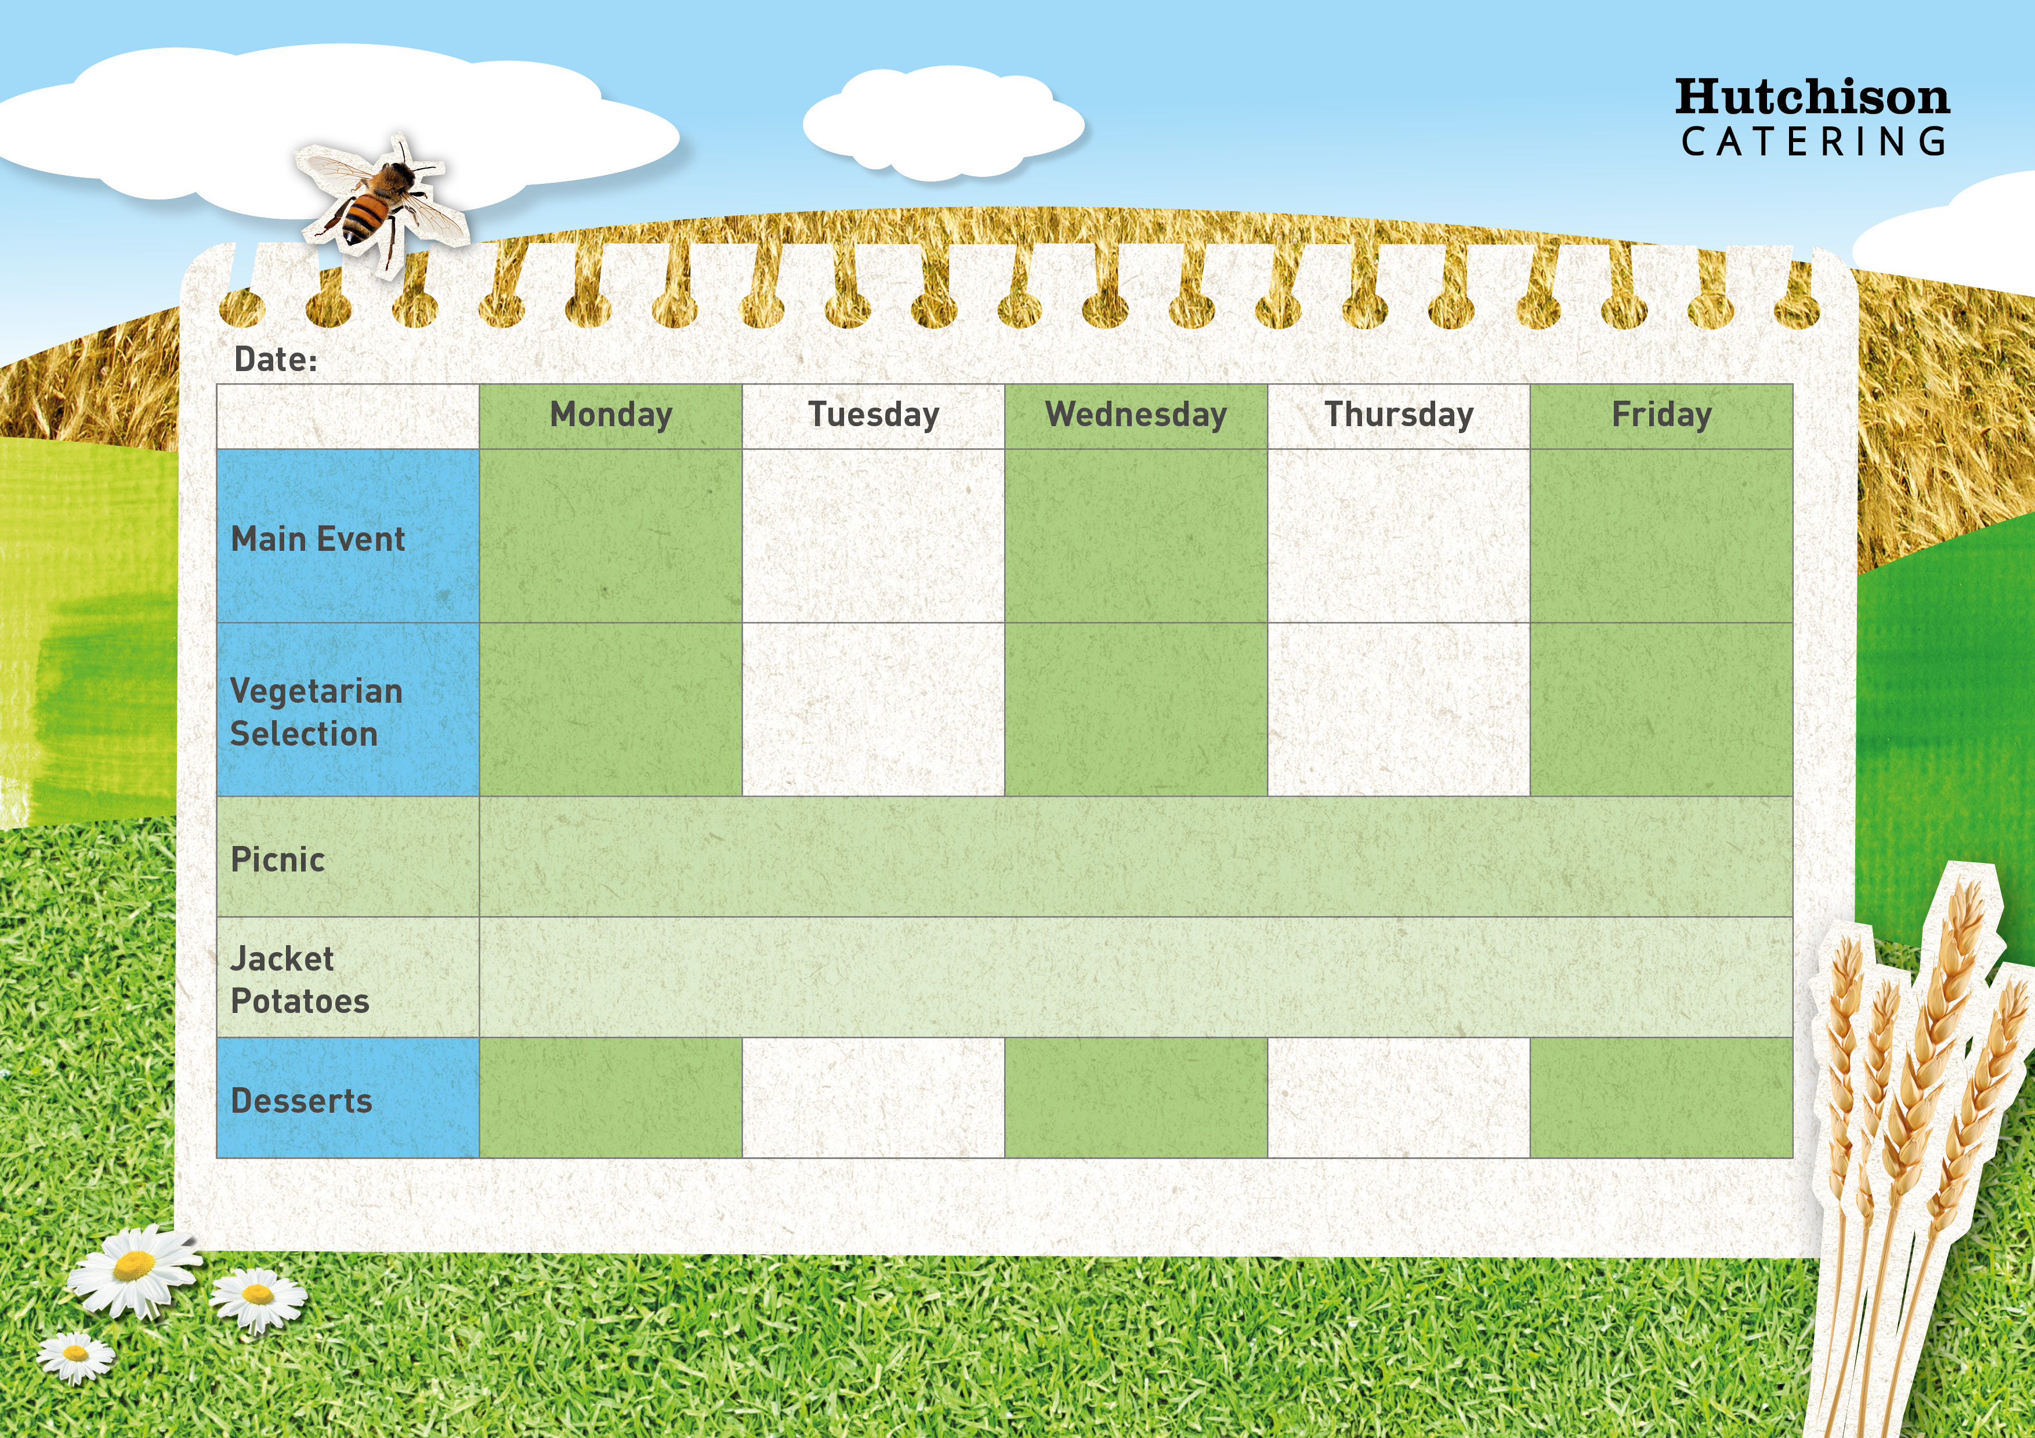

**Freshly Prepared Sandwich with Mixed Salad, Healthy Snack,**

**Dessert of the Day or Fresh Fruit**

**Spring Week 1**

**Crispy Baked Jacket Potato with a Choice of Fillings, Mixed Salad**

**Dessert of the Day or Fresh Fruit**

**Available Daily:** Fresh Bread, Water, Fresh Fruit and Yoghurt

Artic Roll

Iced Sponge

Marble Cake

Custard Cookies

Chocolate Crunch

Quorn Burger with Chips & Baked Beans or Peas

Vegetable Korma with Rice

& Sweetcorn

Quorn Fillet with Crispy Roast Potato, Yorkshire Pudding, Carrots & Gravy

Plant Based Meatballs in Tomato Sauce with Broccoli

Vegetable Fajitas with Rice & Peas

“Meat Free Monday”

Margherita Pizza with Potato Wedges and Peas

Gluten Free Pork Meatballs in Tomato Sauce

Roast Chicken with, Crispy Roast Potato, Yorkshire Pudding, Carrots & Gravy

Chicken Korma with Rice & Sweetcorn

Fish Fingers with Chips & Baked Beans or Peas