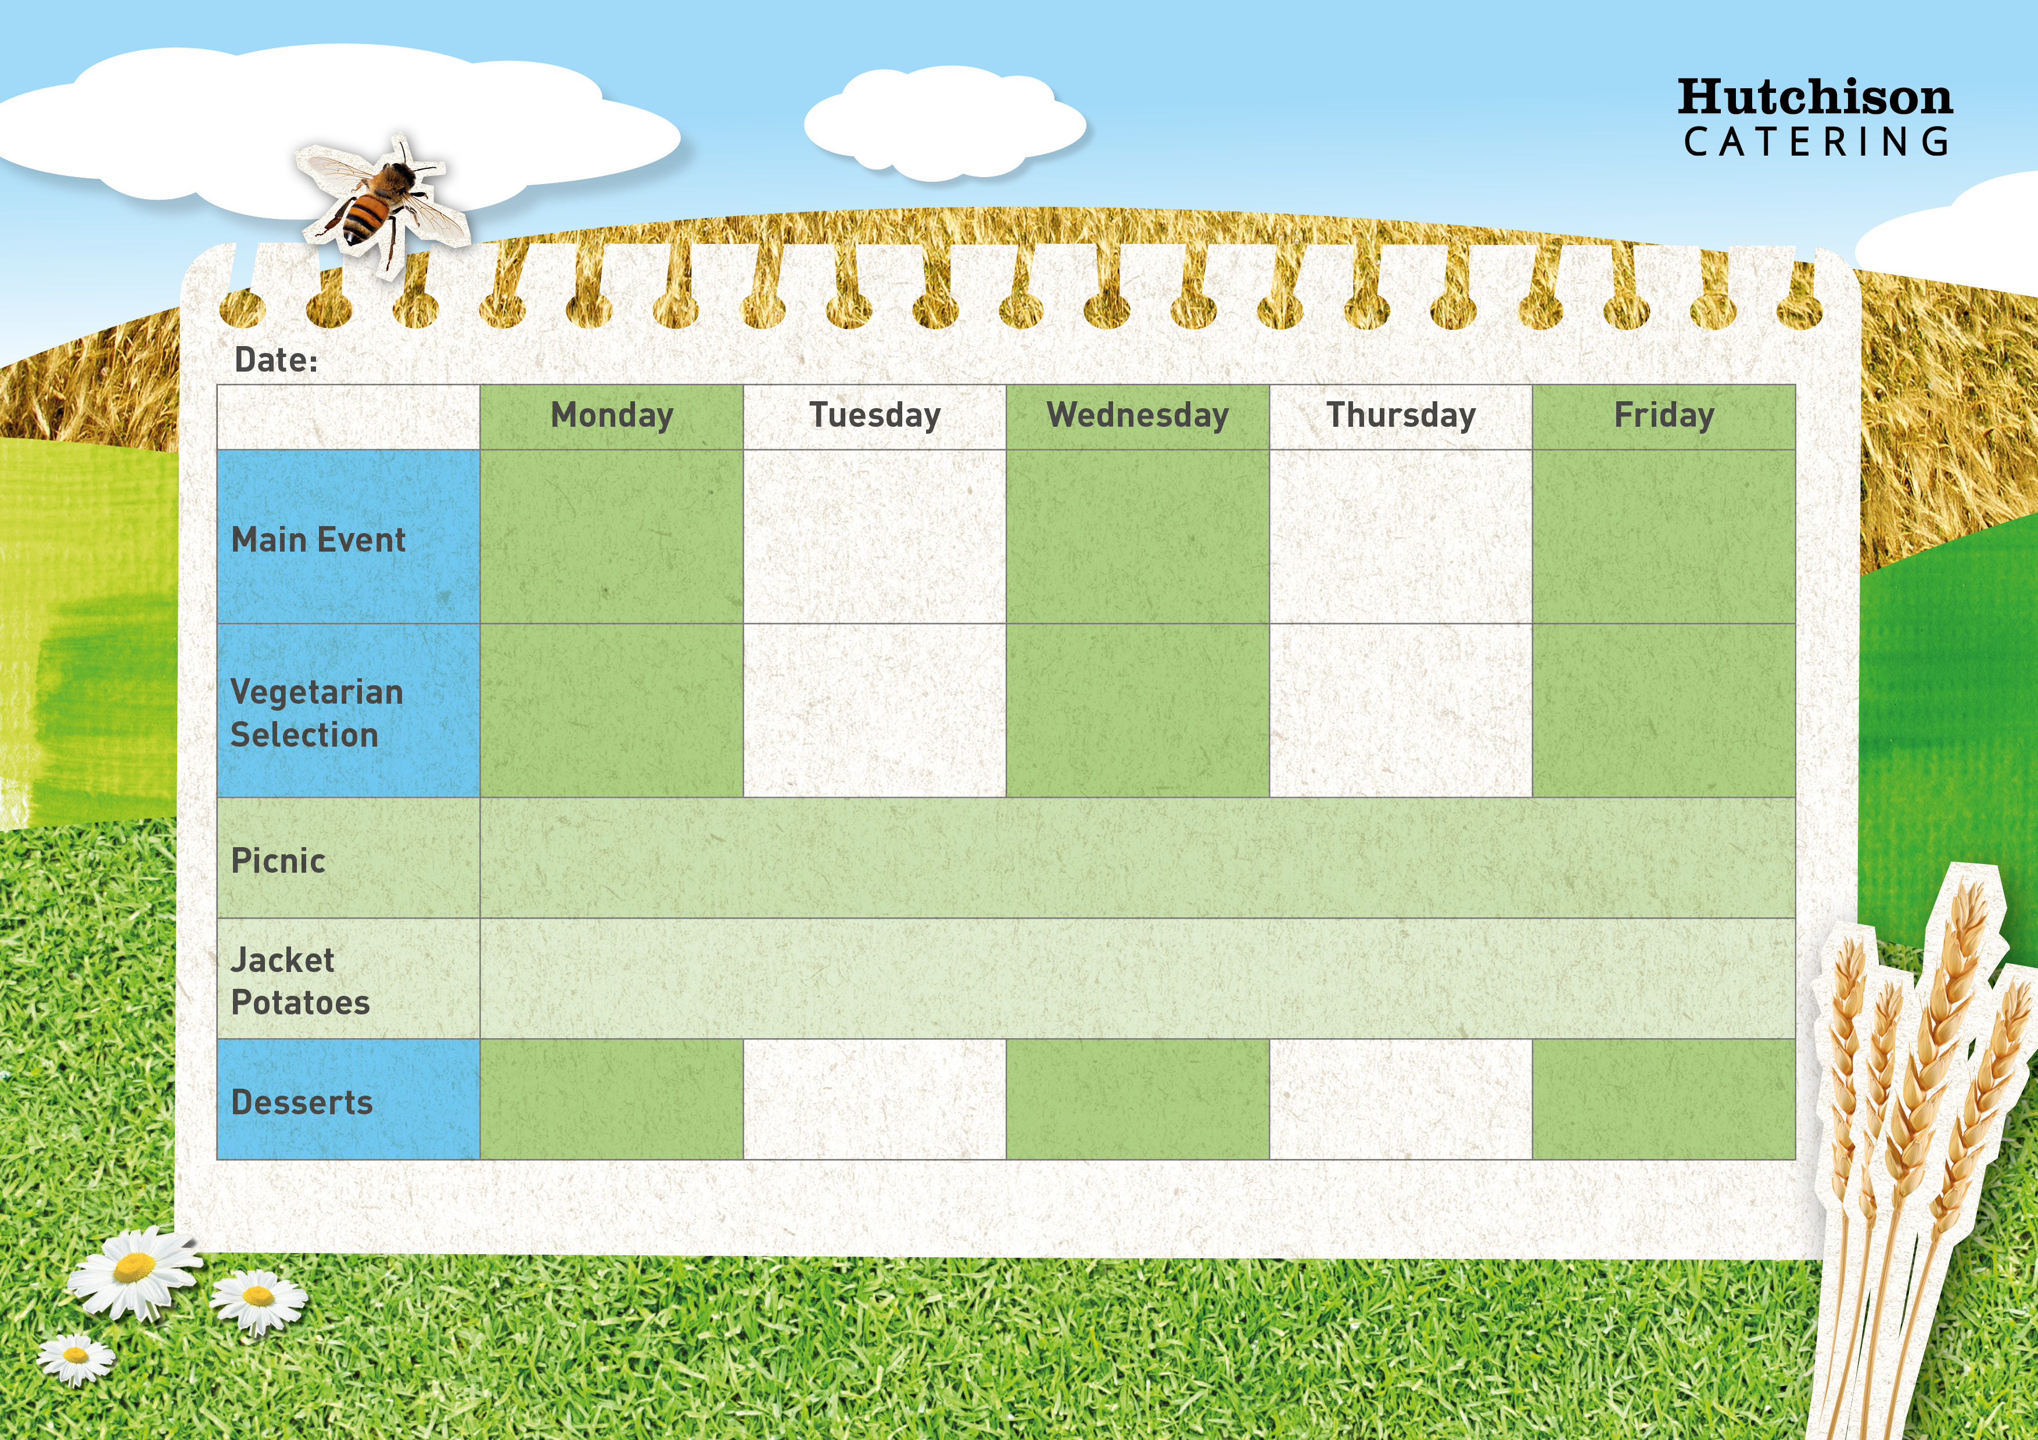

**Freshly Prepared Sandwich, Mixed Salad, Healthy Snack,**

**Dessert of the Day or Fresh Fruit**

Veggie Spaghetti

Bolognese

**Spring Week 2**

Chocolate Biscuit

Homemade Spaghetti Bolognaise with

Sweetcorn

Chicken Tikka Masala with Rice and Naan

Vegetarian Toad in the hole with potato and peas

**Available Daily:** Fresh Bread, Water, Fresh Fruit and Yoghurt

Ice Cream

Chocolate Muffin

Strawberry Jelly

Oaty Biscuits

**Crispy Baked Jacket Potato with a Choice of Fillings, Mixed Salad**

**Dessert of the Day or Fresh Fruit**

Quorn Vegan Dippers with Chips & Baked Beans or Peas

All Day Veggie Breakfast with Beans

Pizza Pin Wheel with Peas

Oven Baked Fish Fingers with Chips & Baked Beans or Peas

All Day Breakfast with Beans

“Meat Free Mondays”

Margherita Pizza with Potato Wedges & Peas