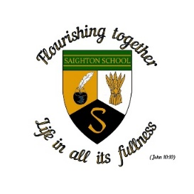

**Saighton Church of England Primary School & Pre-School**

**School term dates 2025-2026**

**Autumn Term 2025**

**Monday 1st September INSET (Staff training day)**

Tuesday 2nd September Pupils return to school

Friday 24th October School closes for half term

**Half term: Monday 27th October – Friday 31st October**

Monday 3rd November School reopens

Friday 19th December School closes for Christmas holidays

**Christmas holiday: Monday 22nd December to Friday 2nd January**

**Spring Term 2026**

**Monday 5th January INSET (Staff training Day)**

Tuesday 6th January School reopens

Friday 13th February School closes for half term

**Half term: Monday 16th February – Friday 20th February**

Monday 23rd February School reopens

Tuesday 31st March School closes for Spring Break

**Wednesday 1st April INSET (Staff training Day)**

**Spring Break: Thursday 2nd April – Friday 17th April**

**Summer Term 2026**

Monday 20th April School reopens

Monday 4th May Bank holiday

Friday 22nd May School closes for half term

**Half term Monday 25th May - Friday 29th May**

**Monday 1st June INSET (Staff training day)**

Tuesday 2nd June School reopens

Tuesday 21st July School closes for summer holiday

**Wednesday 22nd July INSET (Staff training day)**